Process Definition Document (PDD)

*Process Name: Top Box Office Movies (US)*

Table of Contents

**Introduction** **1**

Purpose of the Document 1

Objectives 1

Process Key Contact 1

Minimum Prerequisites for Automation 1

**As-Is Process Description** **2**

Process Overview 2

Applications used in the Process 3

As-Is Process Map 3

**To-Be Process Description** **3**

Detailed Process Map 3

Robot Type 4

Business Exceptions Handling 4

Known Exceptions 4

Unknown Exceptions 4

System Exceptions Handling 4

**Other Observations** **5**

**Additional sources of process documentation** **5**



# Introduction

## Purpose of the Document

The Process Definition Document outlines the business process chosen for automation using UiPath Robotic Process Automation (RPA) technology.

The document describes the sequence of steps performed as part of the business process, the conditions and rules of the process prior to automation and how they are envisioned to work after automating it, partly or entirely. This specifications document serves as a base for developers, providing them with the details required for applying robotic process automation to the selected business process.

## Objectives

The business objectives and benefits expected by the Business Process Owner after automation of the selected business process are:

* Getting all the top box office movies from IMDb Website.
* Sending all the top box office movies’ data to the user mail.
* The process should run once a week (Every Tuesday at 12 AM)

## Process Key Contact

The specifications document includes concise and complete requirements of the business process and it is built based on the inputs provided by the process Subject Matter Expert (SME)/ Process Owner.

The Process Owner is expected to review it and provide signoff for accuracy and completion of the steps, context, impact and a set of process exceptions. The details are to be included in the table below.

|  |  |  |  |
| --- | --- | --- | --- |
| Role | Name | Contact Details  (email & phone number) | Notes |
| Process Owner | Fayad Mohamed | Fayad99955@yahoo.com |  |
| Business Analyst | Fayad Mohamed | Fayad99955@yahoo.com |  |

## Minimum Prerequisites for Automation

|  |  |
| --- | --- |
| Met (Y/N) | Prerequisites |
| Y | A filled in and completed Process Definition Document |
| Y | Closure of any open process questions |
| Y | Environment set up |
| Y | Test Data to support development and testing |
|  | User access and creation of user accounts (licences, permissions, restriction to create accounts for robots) |

# As-Is Process Description

## Process Overview

General information about the process selected for RPA prior to automation.

|  |  |  |
| --- | --- | --- |
| # | Item | Description |
| 1 | Process Full Name | Coming Soon Movies (US) |
| 2 | Process Area | Personal |
| 3 | Department | Fun |
| 4 | Process Short Description  (operation, activity, outcome) | Gets Coming Soon movies' information in US and mails it to the user account. |
| 5 | Role(s) required for performing the process | Any |
| 6 | Process schedule and frequency | user triggered |
| 7 | # of items processed /reference period | 10 |
| 8 | Process execution time | 4 – 5 seconds/movie |
| 9 | Peak period(s) | N/A |
| 10 | Transaction Volume During Peak period | N/A |
| 11 | Total # of FTEs supporting this activity | N/A |
| 12 | Expected increase of volume in the next reference period | N/A |
| 13 | Level of exception rate | N/A |
| 14 | Input data | IMDb link as assets on the orchestrator. |
| 15 | Output data | All Coming Soon movies’ details sent to the user mail as excel file. |

*Add more rows to the table to include relevant data for the automation process. No fields should be left empty. Use “n/a” for the items that don't apply to the selected business process.

## Applications used in the Process

The table includes a comprehensive list of all the applications that are used as part of the process to be automated to perform the given steps in the flow.

|  |  |  |  |  |  |
| --- | --- | --- | --- | --- | --- |
| # | Application Name & Version | System Language | Thin/Thick Client | Environment/ Access Method | Comments |
| 1 | Chrome | English | Thin | PC |  |
| 2 | Microsoft Excel | English | Thin | PC |  |
| 3 | Mail | English | Thin | PC |  |

*Add more rows to the table to include the complete list of applications.

## As-Is Process Map

**High Level As-Is Process Map:** This chapter depicts the As-Is business process at a High Level to enable developers to have a high-level understanding of the current process.

|  |  |  |  |
| --- | --- | --- | --- |
| # | Step Action/Description | Screenshot | Remarks |
| 1 | Open Chrome browser with the provided IMDb link. |  |  |
| 2 | Click Menu. |  |  |
| 3 | Click Coming Soon |  |  |
| 4 | Read all Coming Soon movies’ names |  | Data Scrapping |
| 5 | Save movie’s data (storyline, duration, type and date) | N/A |  |
| 6 | Write all the movies’ data to an excel file. |  |  |
| 7 | Send the excel file to the provided user mail | N/A |  |

# To-Be Process Description

## Detailed Process Map

**Detailed Process Map:** This chapter depicts the To-Be automation process at a detailed view to enable developers/COE to see the workflows involved in the RPA solution

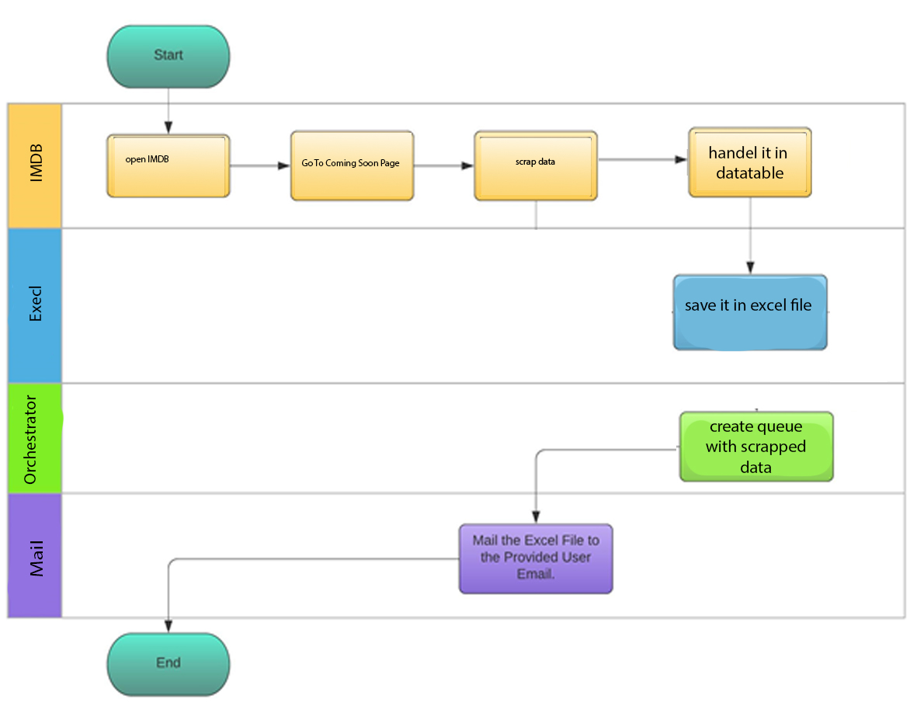

|  |  |  |  |  |  |
| --- | --- | --- | --- | --- | --- |
| **Workflow Name** | **Description** | **Pre-conditions** | **Post-actions** | **Arguments** | **Notes** |
| 1 – Open_IMDB. | Opens the IMDb web in a new session of chrome browser. | Internet Connection. | IMDb home page is opened successfully. |  |  |
| IMDb_GetComingSoon | go to Coming Soon movies page | An IMDb page is opened(any page). | Coming Soon page exist |  |  |
| IMDB_scrap_data. | Scrap movies data and save in in excel sheet | An Coming Soon page is opened | Coming Soon page exist | Out_movie |  |
| orchestrator | Uploads order information to orchestrator queue | Robot is connected to orchestrator | order information uploaded to orchestrator | In_MoviesDT |  |
| MailMoviesData | sending mail with attached files and correct title | -internet connection  - Successful export of order information in the form of Excel file. | Send Mail correcttly |  | Excel file is saved in the project directory |

## Robot Type

|  |  |  |  |  |
| --- | --- | --- | --- | --- |
| # | Attended | Unattended | Trigger | Comments |
| 1 |  | ✓ |  |  |

## Business Exceptions Handling

The Business Process Owner and Business Analysts are expected to document below all the business exceptions identified in the automation process. These can be classified as:

### Known Exceptions

The table below reflects all the business process exceptions encountered during the process evaluation and documentation. These are known exceptions that occurred before. For each of these exceptions, define a corresponding expected action that the robot should complete if it encounters the exception.

|  |  |  |  |  |
| --- | --- | --- | --- | --- |
| BE # | Exception Name | Step | Parameters | Action to be Taken |
| 1 | Incorrect IMDB URL | 1 | IMDB doesn’t open. | Log the exception and End the Process. |

### Unknown Exceptions

For all other unanticipated or unknown business (process) exceptions, the robot should:

* send an email to [fayad99955@yahoo.com](mailto:fayad99955@yahoo.com) and attach a screenshot of the screen with the error message.

## System Exceptions Handling

A comprehensive list of all errors, warnings or notifications should be consolidated here with the description and action to be taken, for each, by the robot.

Errors identified in the automation process can be classified as:

|  |  |  |  |  |
| --- | --- | --- | --- | --- |
| SE # | Exception Name | Step | Parameters | Action to be Taken |
| 1 | Incorrect Page URL. |  | The page doesn’t open | Log the exception and End the Process. |

For all the other unanticipated or unknown system exceptions, send an email to **fayad99955@yahoo.com** and attach a screenshot of the error message.

# Other Observations

Include below any other relevant observations you consider needed to be documented here.

* N/A

# Additional sources of process documentation

* N/A